**Assignment 0 - Test Assignment Submission**

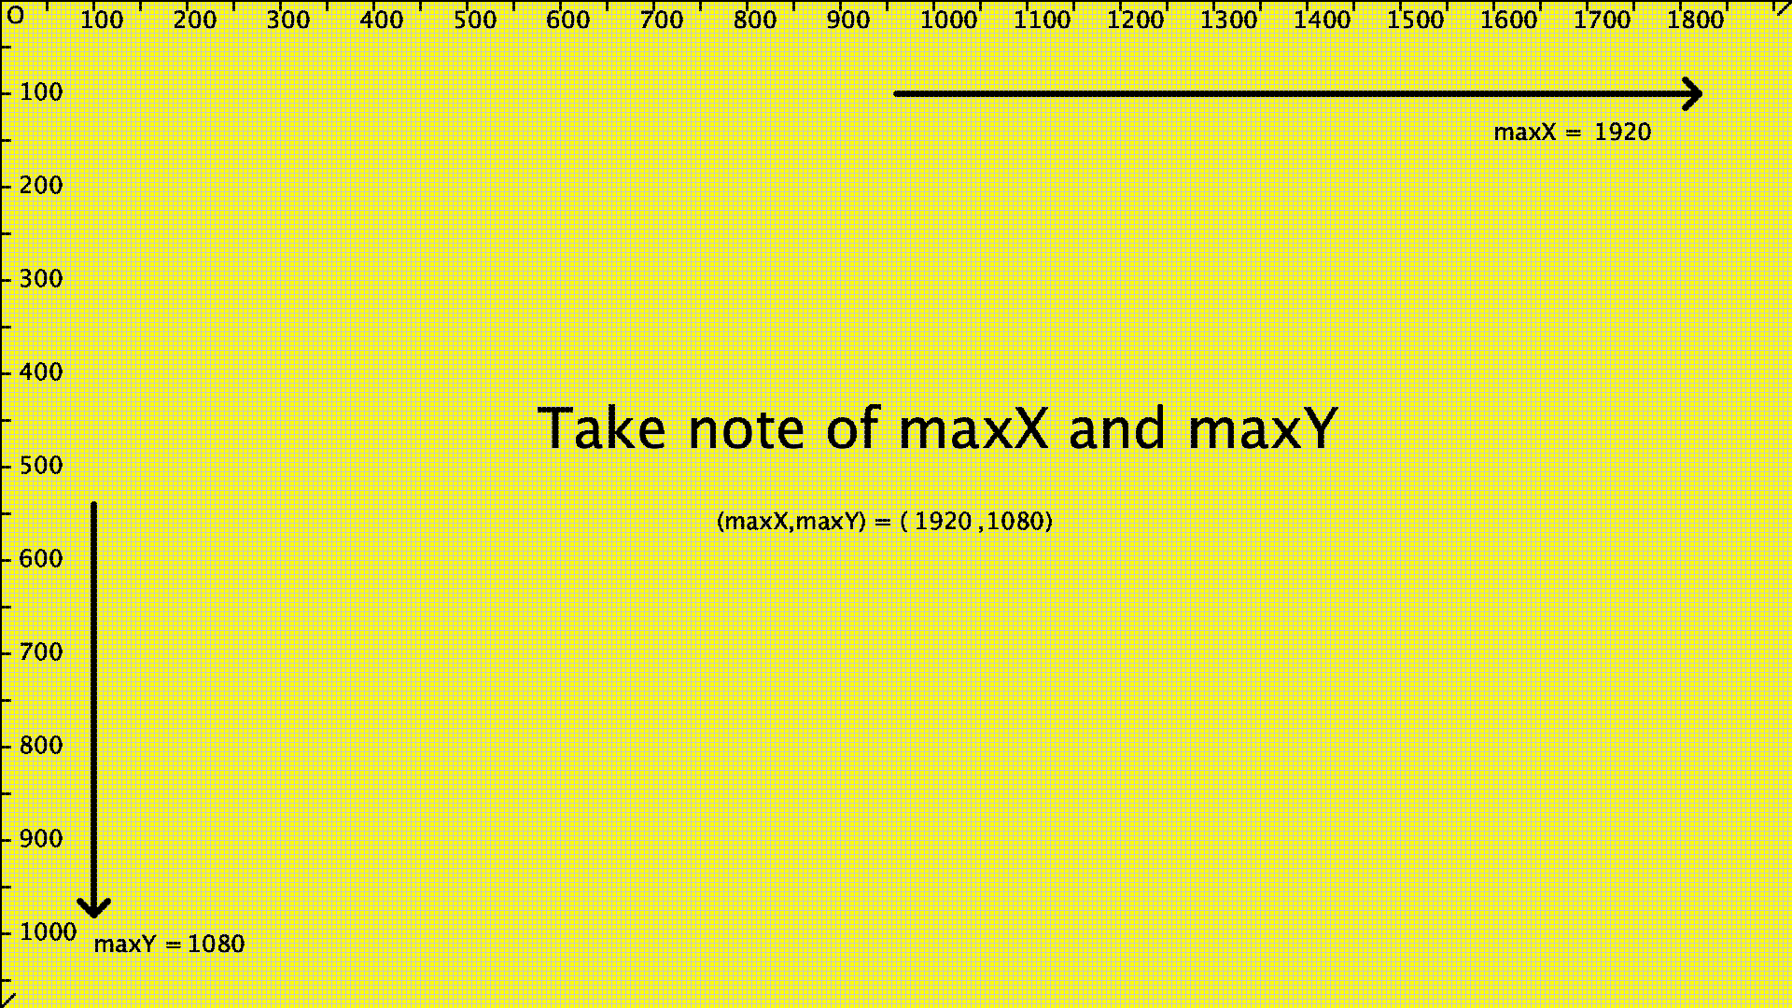

***Note:*** *If you haven’t done so already, go through the docs “Introduction” and “Course Apps Setup” first before attempting this assignment*

**Goal**

This assignment is to make sure you are familiar with the APDE app and for you to test out the process of submitting assignments.

**Instructions**

1. Find the **screen_grapher** program and change the name and add “**_”** andyour assigned course id at the end. Eg **screen_grapher_sa20.** This is important otherwise, we can’t grade your assignment
2. Run the screen_grapher program
3. Take a screenshot of the output of the program
4. Note down maxX and maxY
5. Submit your assignment at this submission link: [**here**](https://docs.google.com/forms/d/e/1FAIpQLSd3X5NEZSCKsrv2wmusAKUI_PBKmOc5mHUhLzjxDK0NEPv9DQ/viewform?usp=sf_link)